Project Design Document

1. Design Intent
- What experience are you trying to create?
As a child we sometimes made our dolls dance with our hands but now a days as children are being given electronics to play with, they often lose the experience of playing with physical toys. This integrates both technology and the fun we had as we “choreographing” dances for our dolls.

- Who is it for?
This is a toy for children.

2. Inspiration & References
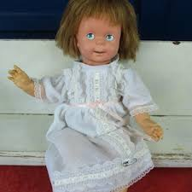
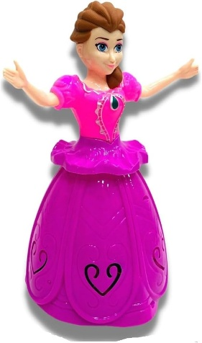
Childrens toy that Doll’s clothes
just keeps moving
forward

3. User Journey
The user opens the App
The click the buttons on the app that corresponds to the relative position of the points on the platform in the order that they want it to.
They click on OK when they are satisfied with the order
Click on START to start the choreography of the doll.

4. Success Criteria
- The doll appropriately reaches the points we want it to and returns to the home point after it is done
- The IR Sensor detects the edge of the platform (the lack of surface) and stops.
- The stepper motor spins after reaching each point

5. System Overview
Component |  | Where it is used
ESP32 Microcontroller |  | Runs all code , connected to App through BLE, controls the 3 motors
2 DC Motors |  | Moves the robot by controlling the wheels
Stepper Motor |  | Spins the upper body of the doll
IR Sensor |  | Detects the edge of the platform and stops the doll before it falls off
Motor Drivers |  | Controls direction and speed of DC motors and stepper Motor via PWM
MIT App Inventor App |  | User interface: Blutooth scan/connect to the ESP32, build sequence (1, 2,3,4 buttons), START/CLEAR
Power Supply |  | Powers ESP32 + motors

6. High-Level Block Diagram
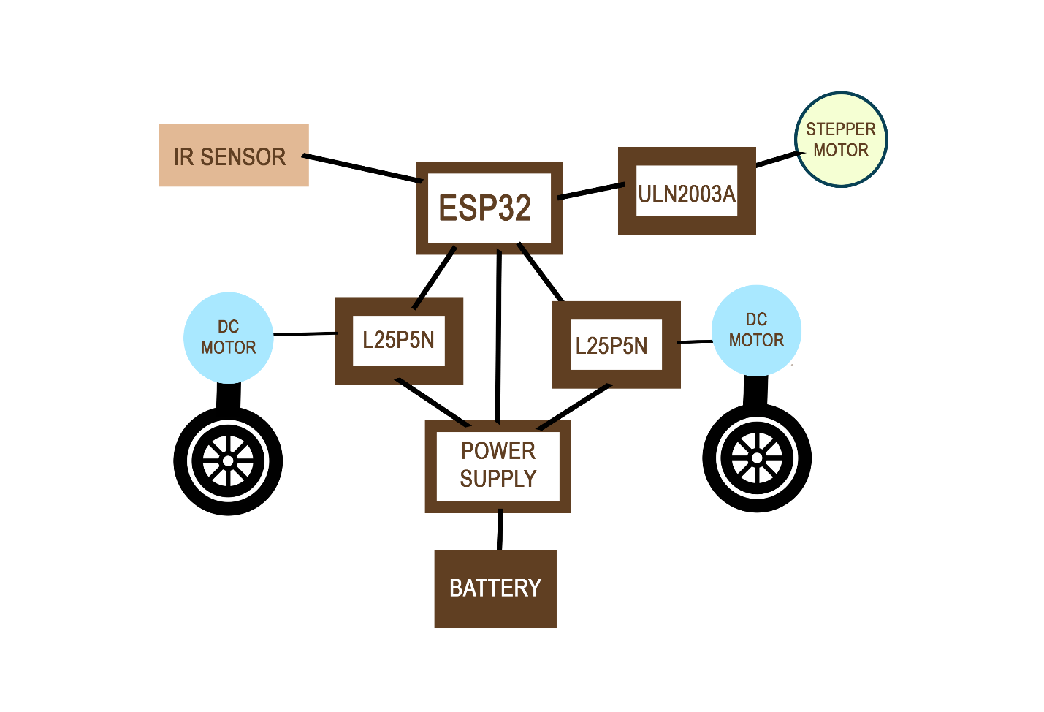

7. Input / Output Mapping
Input | Process | Output
The IR sensor placed in front of the doll that detects the surface of the table. | The IR sensor continuously detects the inputs from the user and runs the sequence only when it detects a surface. | When the IR sensor stops detecting a surface, the doll stops, preventing it from falling off the platform it is kept on.
The order of the points we want the doll to go to | The doll takes the input from the user and then takes the path instructions from the transitions list in the code with predefined functions. It then | The doll moves to the positions in the order entered by the user through the app

8. Sketches & Concepts
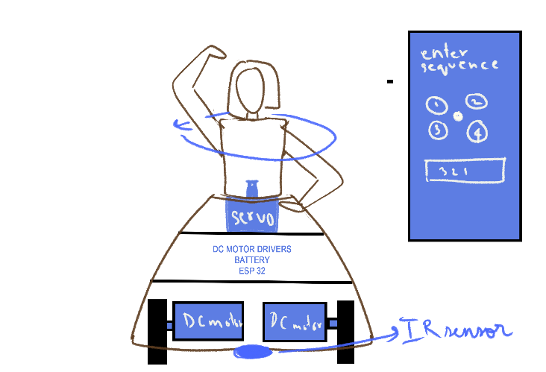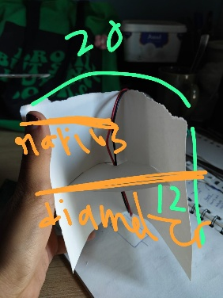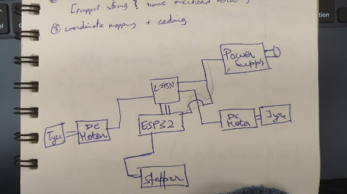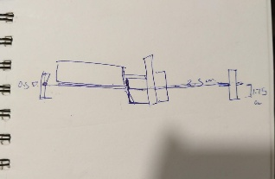

9. Final System Architecture (Labelled)
